Social Media Policy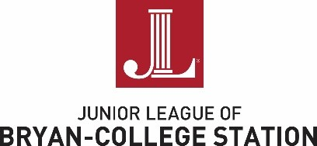

The Junior League of Bryan-College Station, Inc. (JLBCS) members are encouraged to participate in social media as a way to enhance the important work of JLBCS. The purpose of these guidelines are to ensure all members are aware of potential issues and strive to represent JLBCS professionally.

I, ____________________________________ understand that I will be held to the following JLBCS
Social Media Policy.

• Represent JLBCS positively - Protect the reputation of JLBCS through my comments and actions. Post items that would positively reflect JLBCS to our members, community, or donors. Refrain from posting inappropriate photos (i.e. consuming alcohol, inappropriate dress or body language) while at League events; representing League at an event or while wearing attire with the league logo.

• Privacy - Post photos/personal information with the permission of all those included.

• Sharing Information - Respectfully voice ideas and opinions. Keep confidential information confidential.

• Internet History - Think before I post. Content and comments posted on the internet can be traced to the original source. I am always accountable for what I post.

• Positive Messages - Share information that reflects positively on JLBCS and myself as a member of our league and community.

• Photos - Before posting be sure I have the permission of those in the photograph.

• Donors - Treat every business as if they are a Donor/Potential Donor.

• Think globally, act locally - My local posts can have global significance.

• JLBCS Social Media Pages - JLBCS members are responsible for sending information to the PR chair for publication on social media outlets.

______ Yes, you can share my photo on social media.

______ No, you cannot share my photo on social media.

Member Name (Please Print) _________________________________________________

Member Signature _____________________________________Date ________________

Please return via email along with dues and Acceptance/Agreement form by May 31, 2021 to
membership@jlbcs.org

